

Play-Out is when we start from a process model and generate behavior, e.g. traces.

Play-In is when we start from event data and generate a process model, e.g. a Petri net.

Replay is when we start from both a process model and a collection of observed behavior, e.g. traces, and compare these by replaying the traces on the process model.

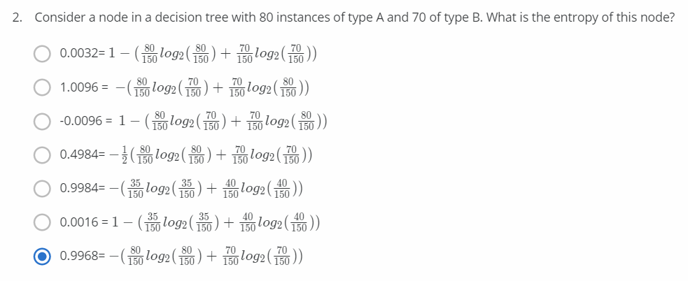

**Entropy** is a measure of the randomness in the information being processed.

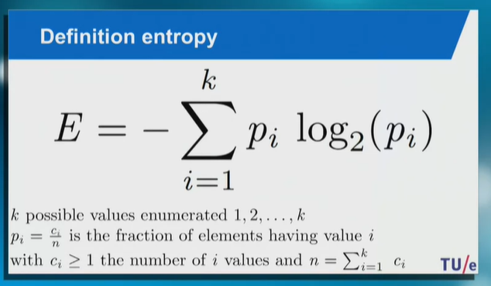

E = - (80/150 log(80/150) + 70/150 log(70/150)) = -(-0.483-0.512) = 0.995

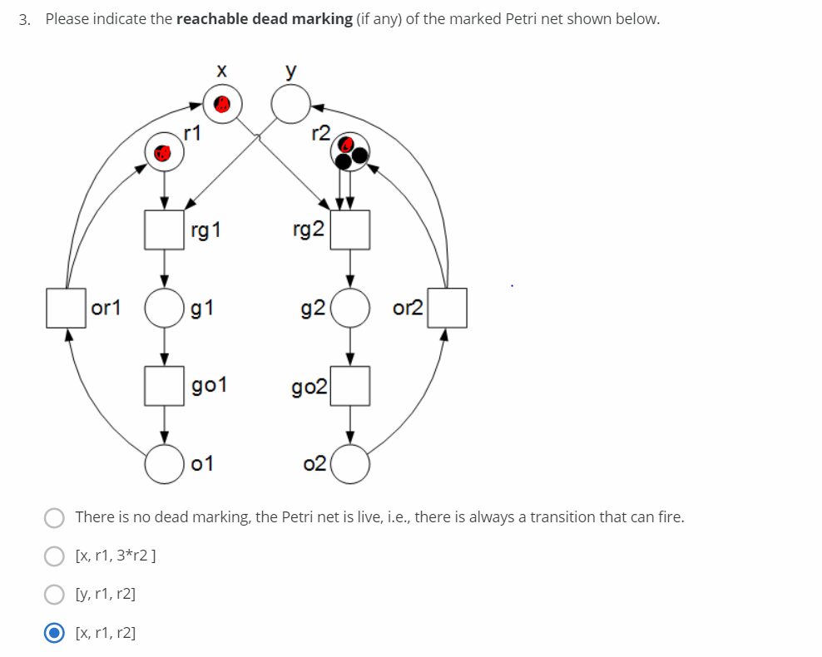

Answer: {x,r1,r2}

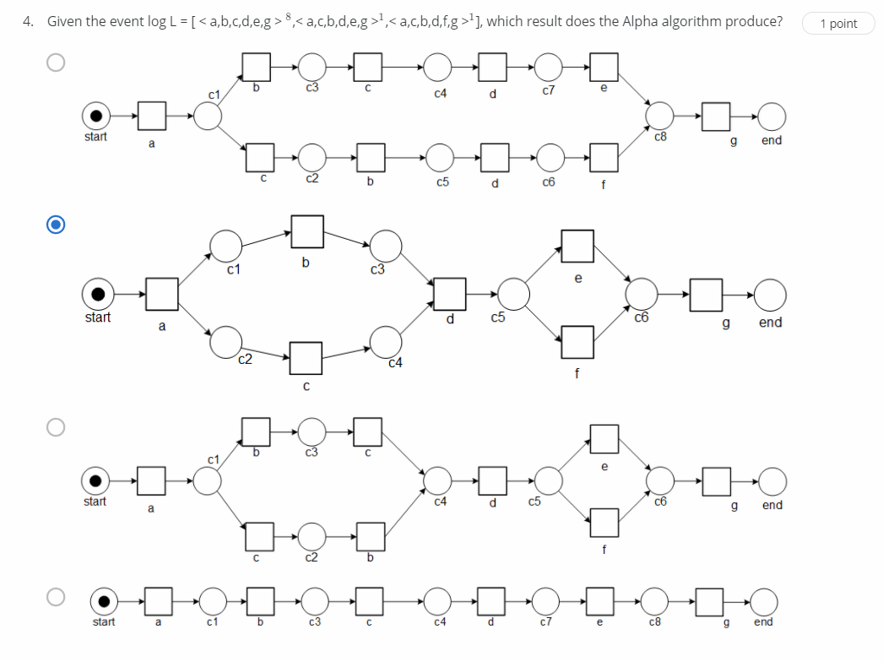

First option: Wrong => <a,c,b,d,e,g>

Second option: Correct => Follows all traces in event log

Third option: Wrong => Even though it follows the event log, more transitions are used to build the model

Fourth option: Wrong => Only one trace is possible <a,b,c,d,e,g>

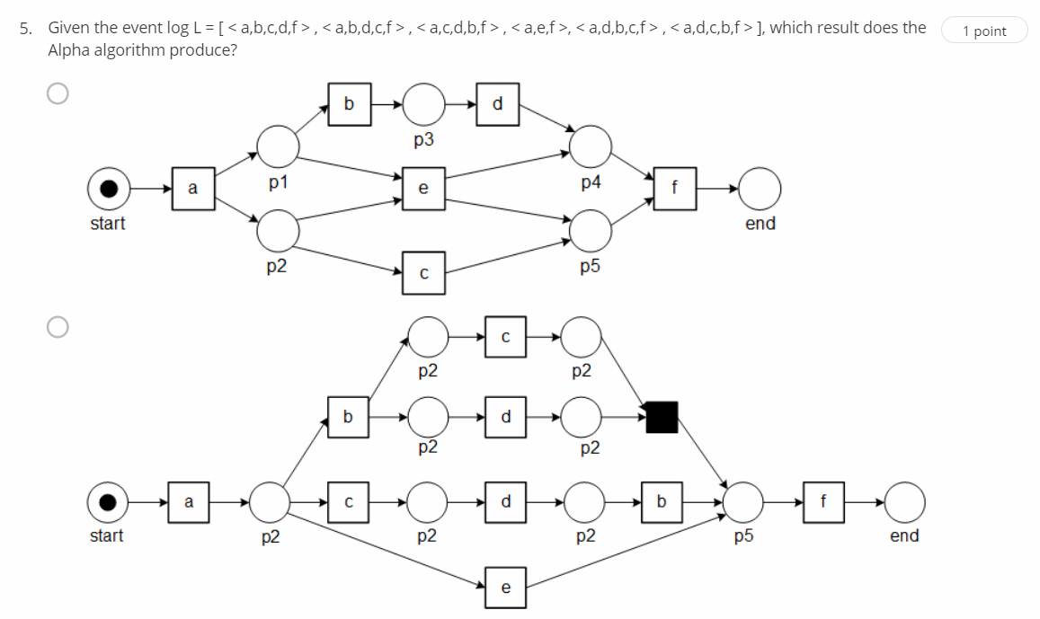

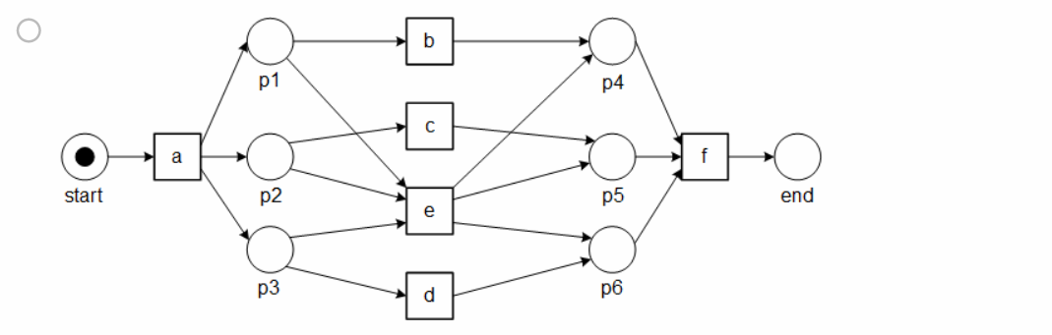

First option: Wrong => <a,c,d,b,f> trace is not possible

Second option: Wrong => <a,d,b,c,f> trace is not possible

Third option: Correct => Satisfies all possibilities

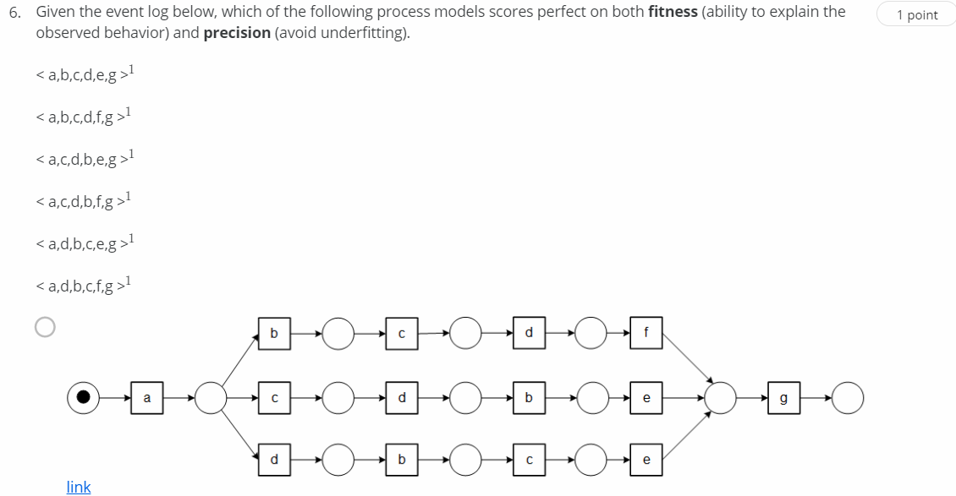

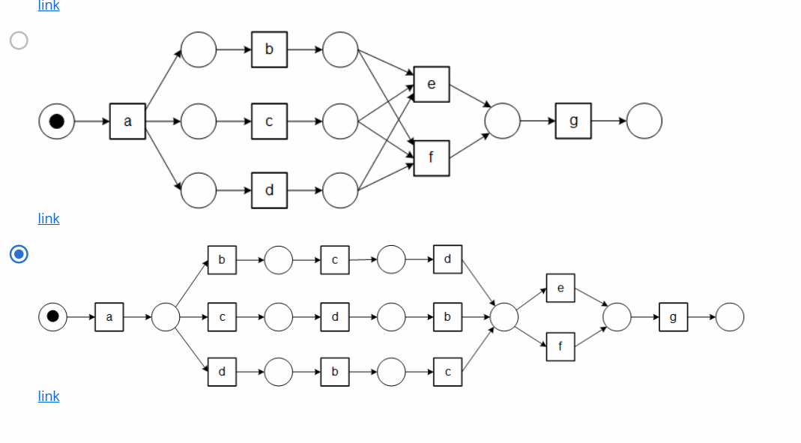

First option: Wrong => <a,b,c,d,e,g> is not possible

Second option: Wrong => It follows all traces in event log but it gives extra traces like <a,b,d,c,e,g>, <a,b,d,c,f,g> etc

Third option: Correct => It exactly fits the event log

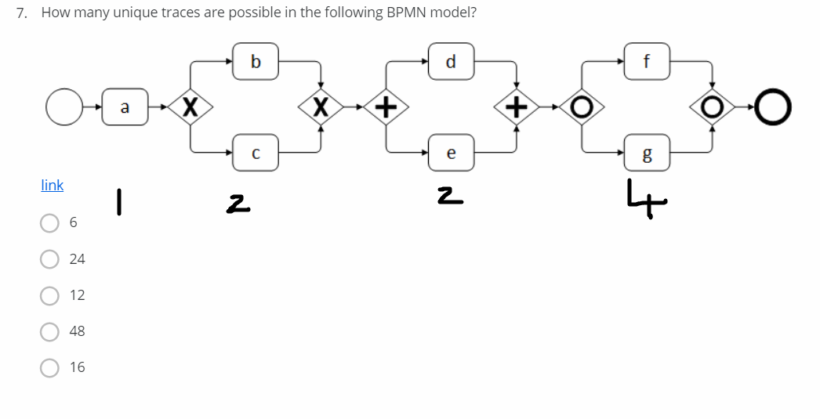

For a => 1 possibility

b & c => b or c => 2 possibilities

d & e => de or ed => 2 possibilities

f & g => f, g, fg, gf => 4 possibilities

Total = 1*2*2*4 = 16

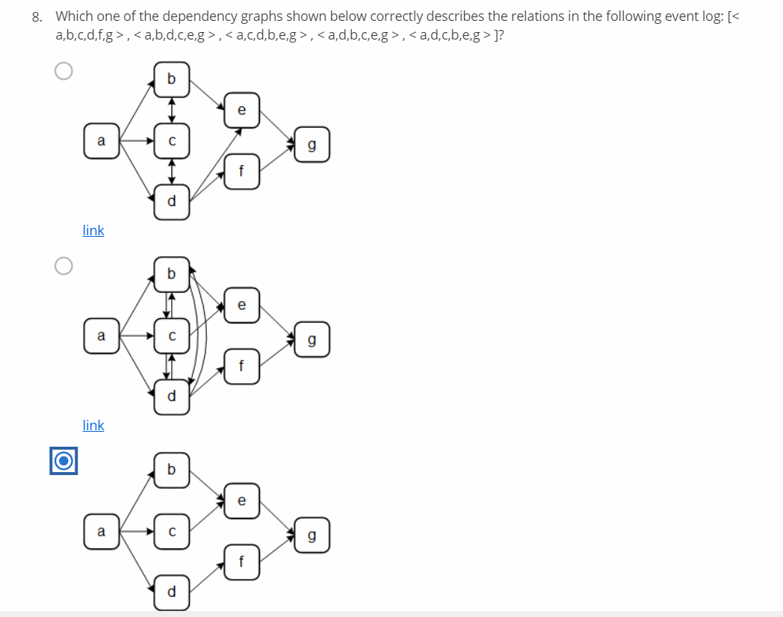

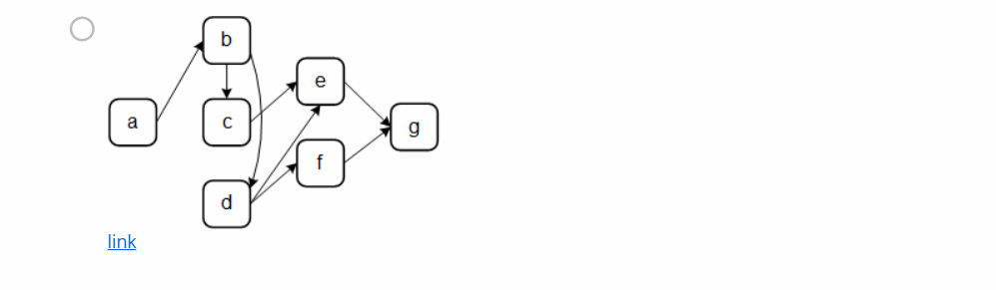

Footprint of the event log:

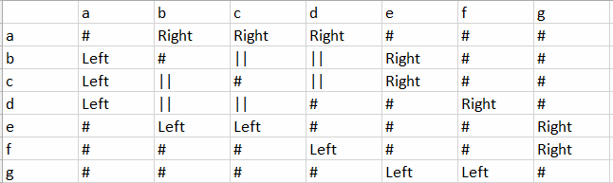



Without considering the parallel dependencies (||), third option is the correct dependency graph

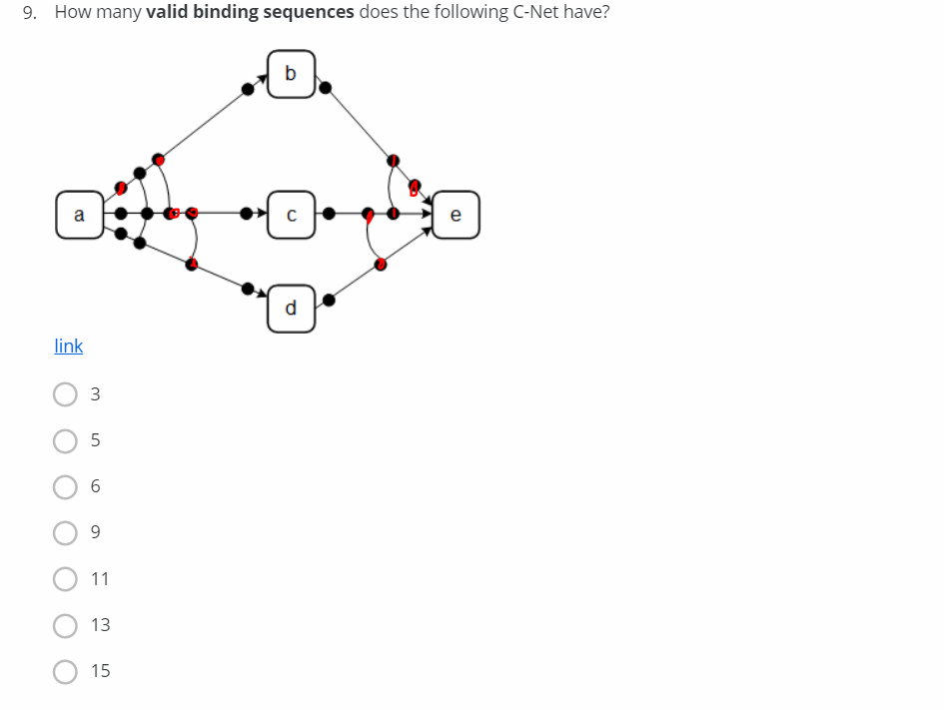

Single binding - 1

Double binding - 2

Total = 1*1+2*2 = 5

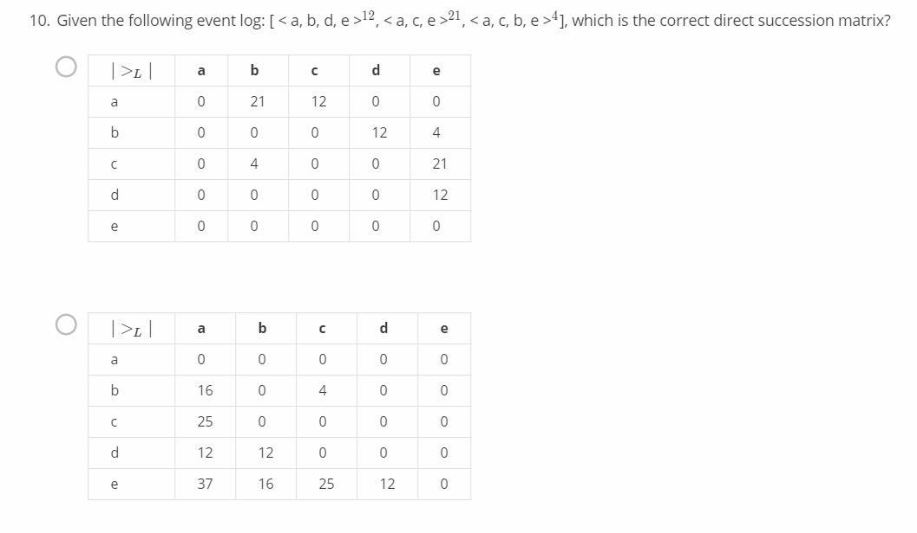

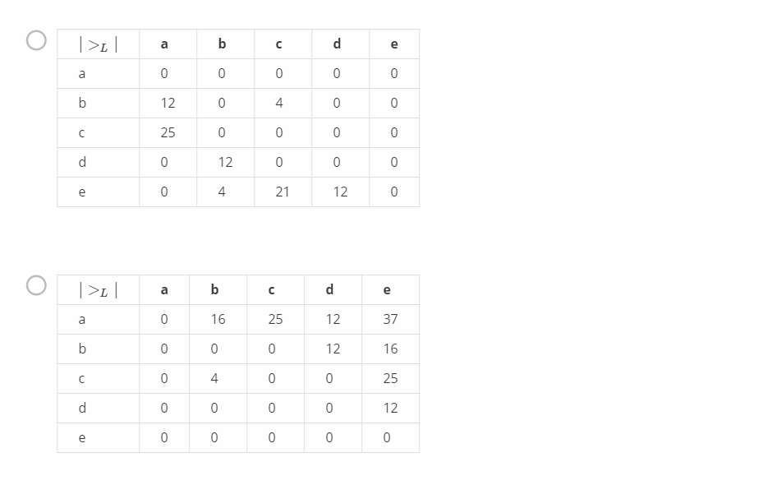

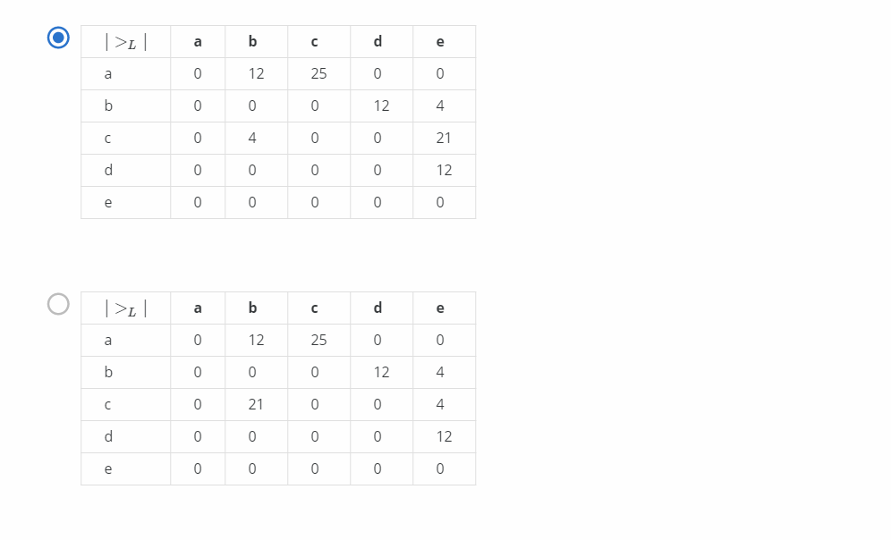

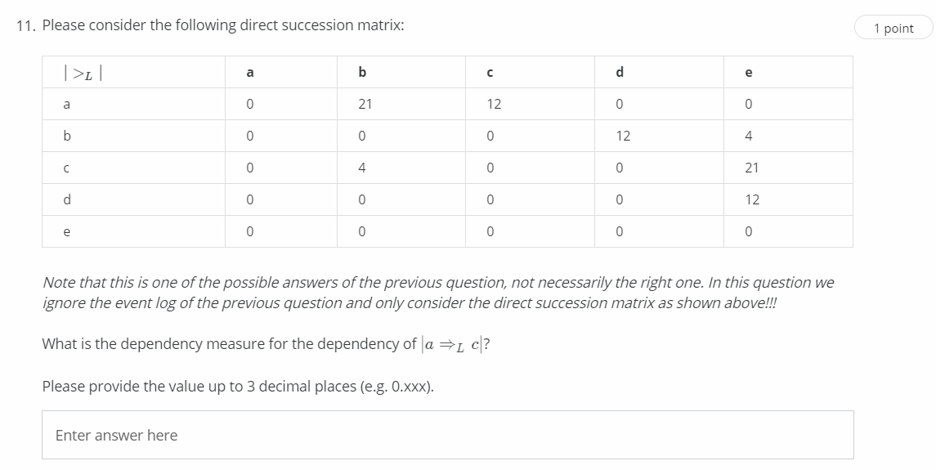

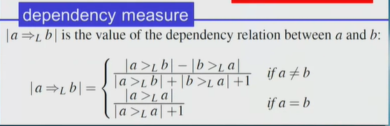

a =>Lc = (12-0)/12+1 = 12/13 = 0.923

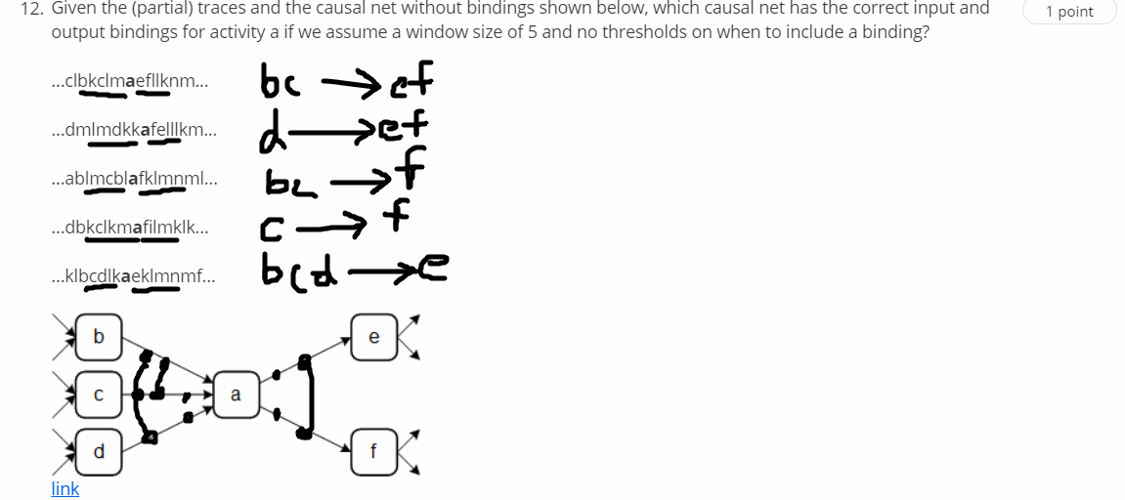

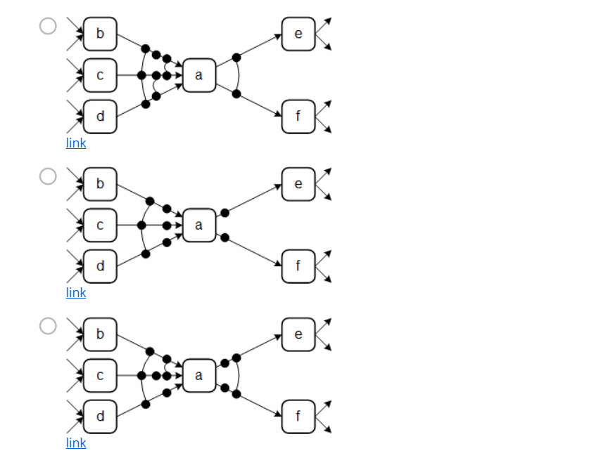

3rd option is the answer

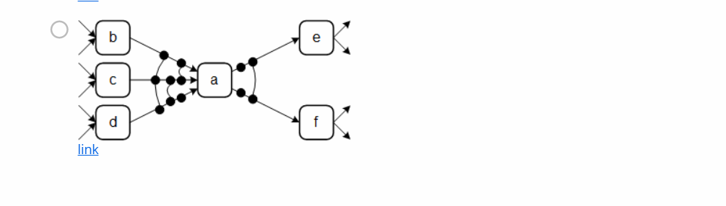

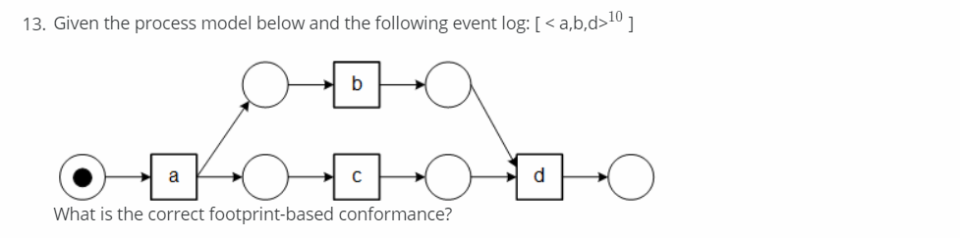

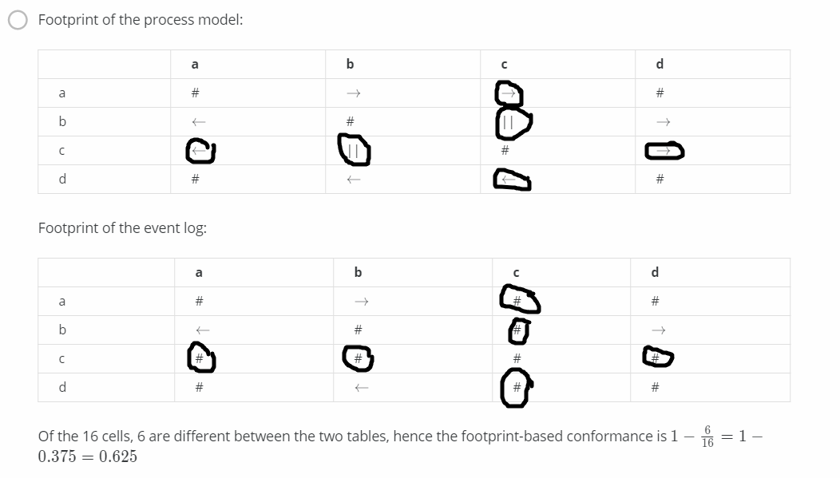

Correct

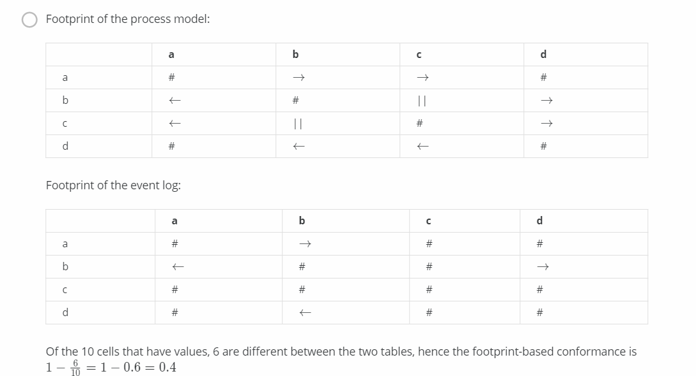

Wrong calculation

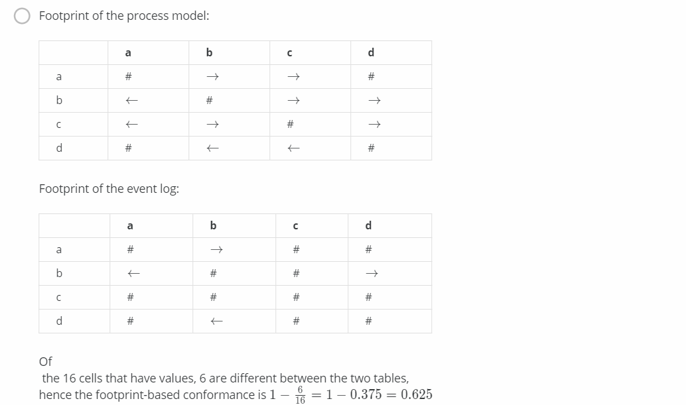

Wrong process model

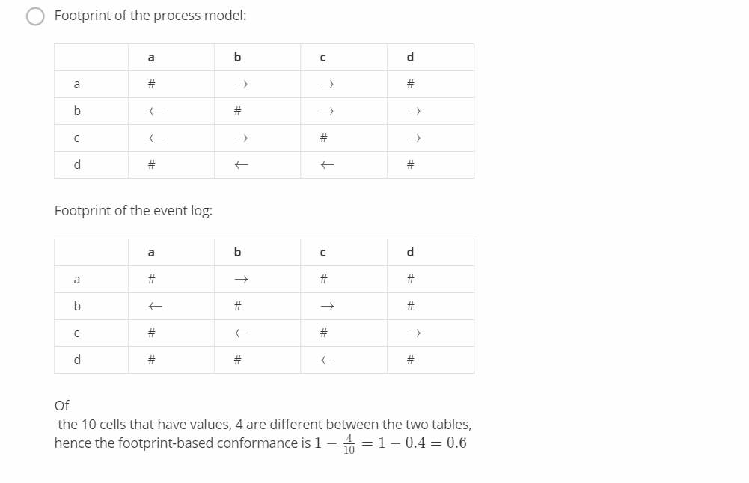

Wrong event log

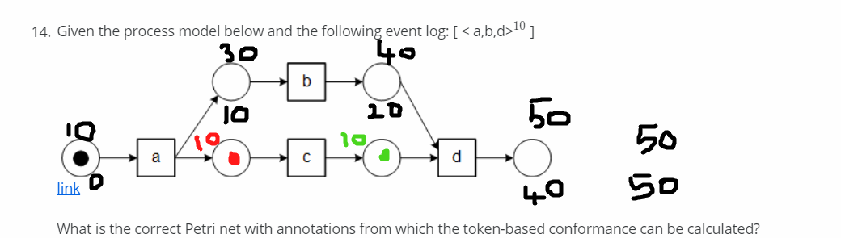

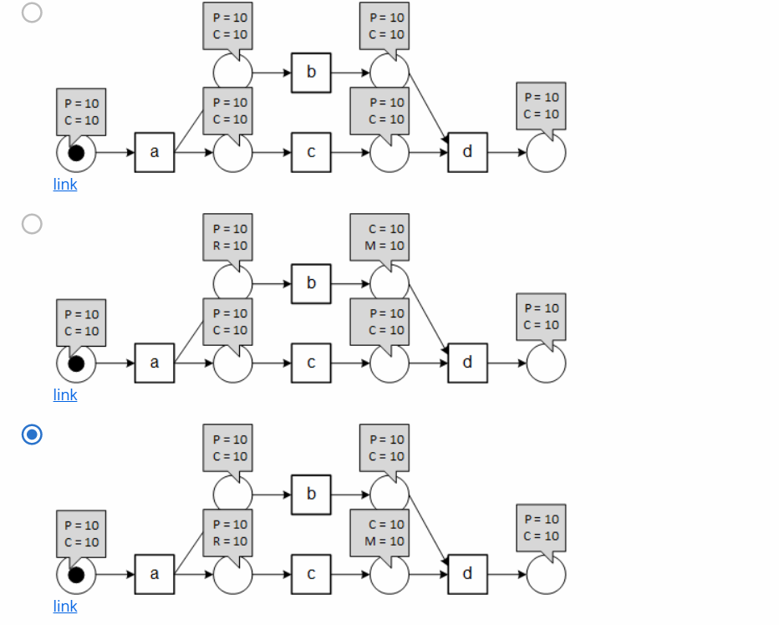

This is correct (up)

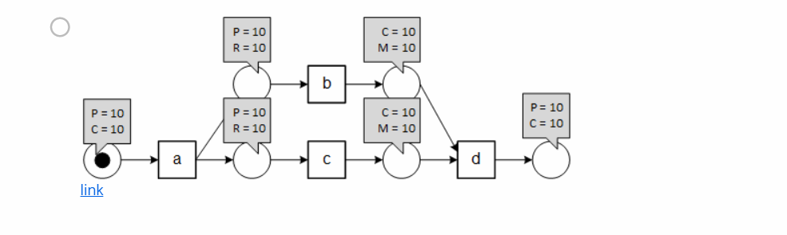

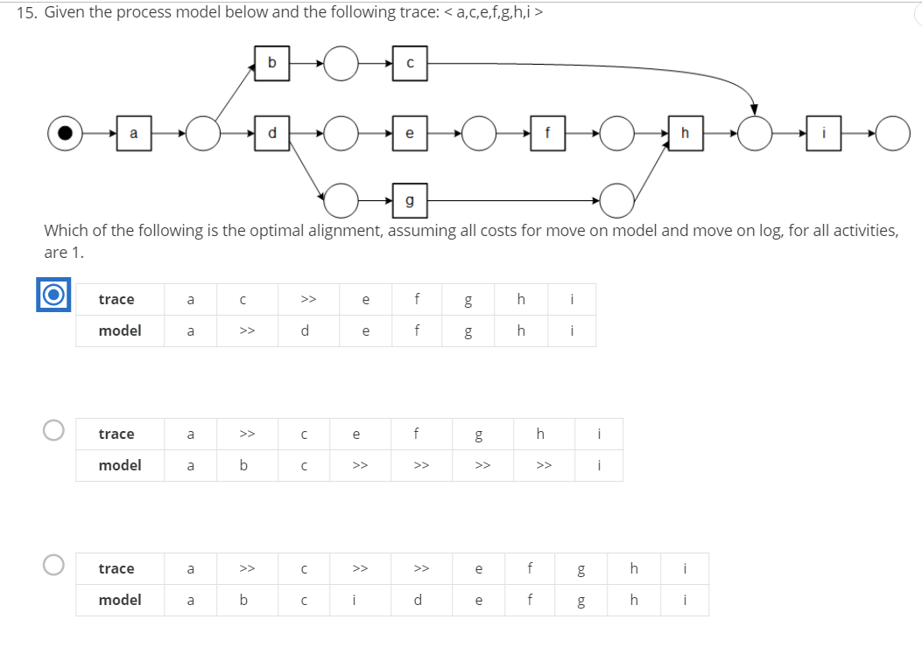

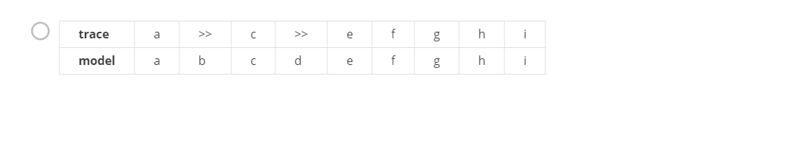

First option: Correct => Optimal alignment as it has least cost function 2

Second option: Wrong => Alignment is correct but has cost function 5

Third & Fourth option: Wrong => Provided model is not possible

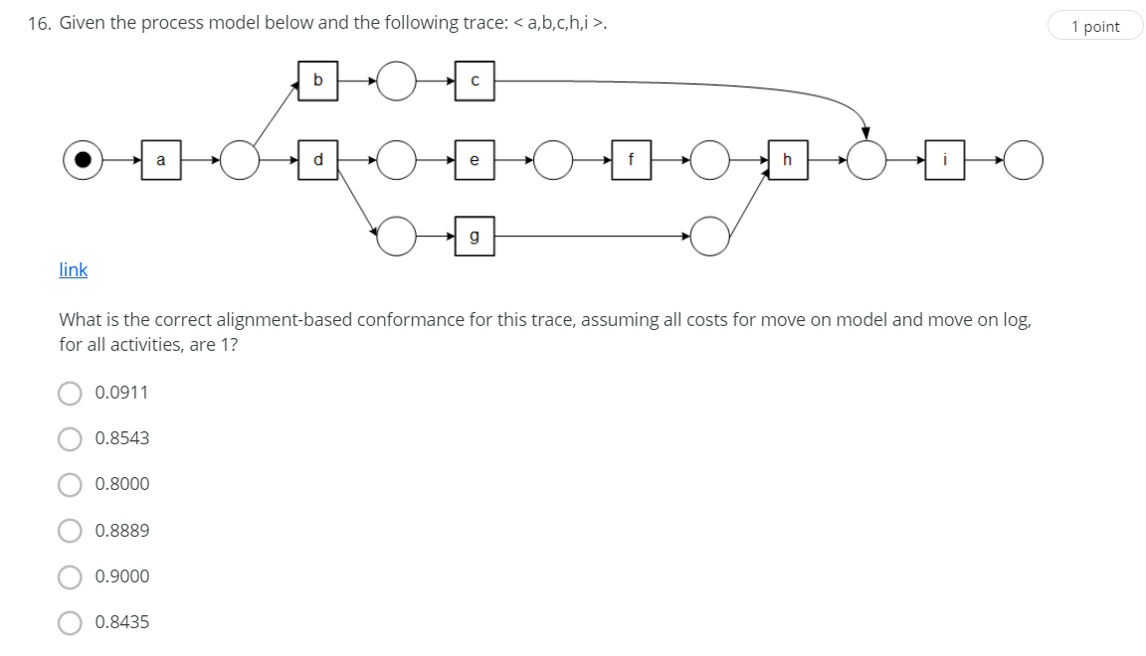

Trace a b c h i

Model a b c >> i

Shortest path: a b c i

Worst case: a b c h i

Conformance = 1-(1/(5+4)) =1-(1/9) = 8/9 = 0.8889

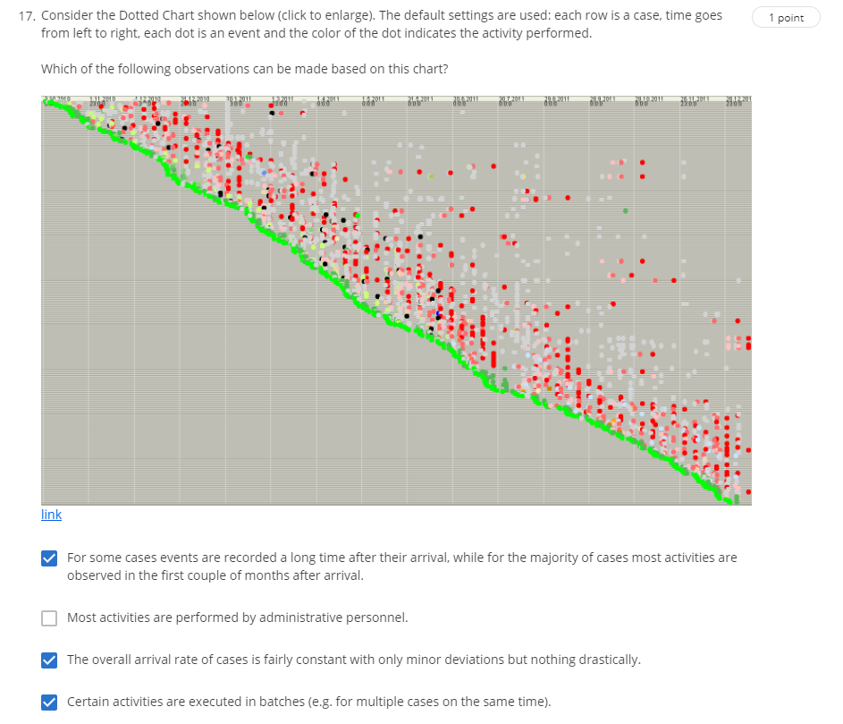

* Most of the activities are happening at the arrival except some outliers
* Overall arrival rate of cases is constant(steep line)
* At a given time multiple cases are happening

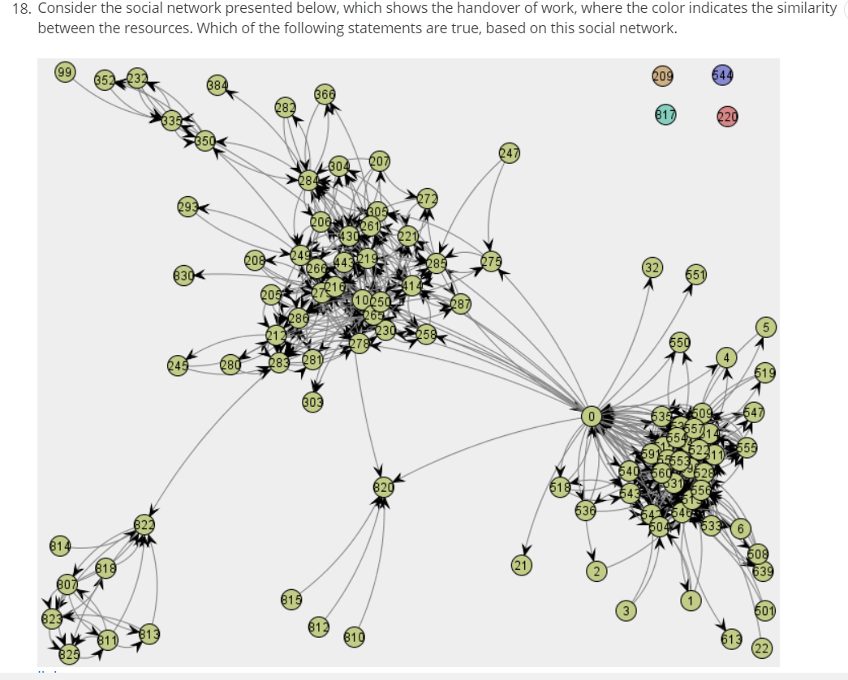

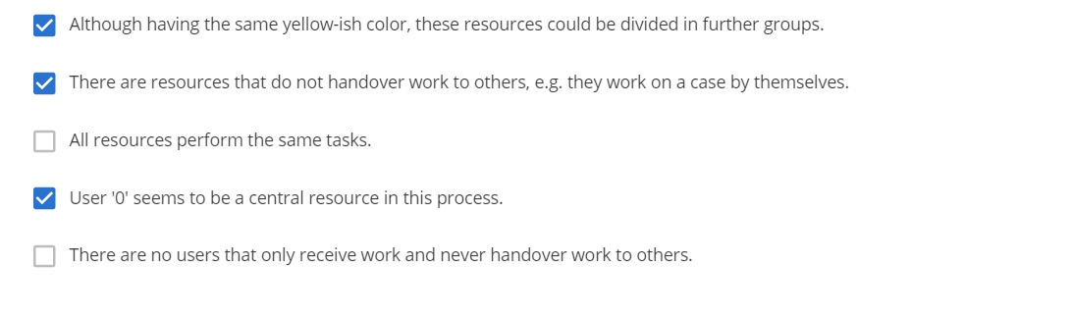

Second option: 32, 551



